SP4C3 WHITE PAPER

## SP4C3 Introduction:

SP4C3 – A Distributed storage, AI cloud computing system based on the Ethereum network. The platform seeks to expand the Ethereum ecosystem and support financial and non-financial applications, using technology to connect the digital and physical worlds. SP4C3 delivers real value for diverse industries and people.

As a new data storage and distribution network, SP4C3 seeks to build a distributed and efficient network based on the Ethereum network. Powerful data storage centers mainly serve as the primary data storage depot for financial institutions and banking systems.

Simultaneously, based on the distributed core of the banking financial business, a highly scalable financial cloud and AI computing system arises. This process completes the open-source AI cloud computing platform to support the innovation of the digital financial system.

SP4C3 will also play an important role in non-financial applications. Through efficient AI computing systems, video analysis, structured AI in combination with different algorithms, of AI workforce to support the application of cloud, including AI intelligent management, automatic face recognition, and intelligent search and intelligent identification, such as disaster control, to help the landing of non-financial applications.

SP4C3 will achieve this mission by stimulating the continuous growth of its economy, continuously supporting and cooperating with third-party projects to achieve application landing and combining technology research and iteration of hardware.

SP4C3 will combine the distributed storage system with AI cloud computing to build a safe and efficient new generation of distributed architecture that aggregates computing power and connects the financial and non-financial systems

## SP4C3: An Industry Leading Distributed Architecture System:

Data storage standards that far exceed the competition.

### A decentralized Financial Message Bus

Dynamic event-driven environment

Simplify IT management for distributed architecture

A one-stop, seamless experience, financial grade, and open source big data platform suite

### 

### An Industry-leading secure data storage solution

SP4C3-Box offers users an industry-leading secure data storage and eases the management and use of data assets by providing data custody for documents such as identity cards, bank cards, driver’s licenses, academic credentials, real estate certificates, and financial statements. Enabled by multiple encryption techniques, watermarking, data escrow, blockchain technology, and biometric verification, SP4C3-Box ensures the secure storage and use of data assets, which users need for data protection.

#### Design Concept

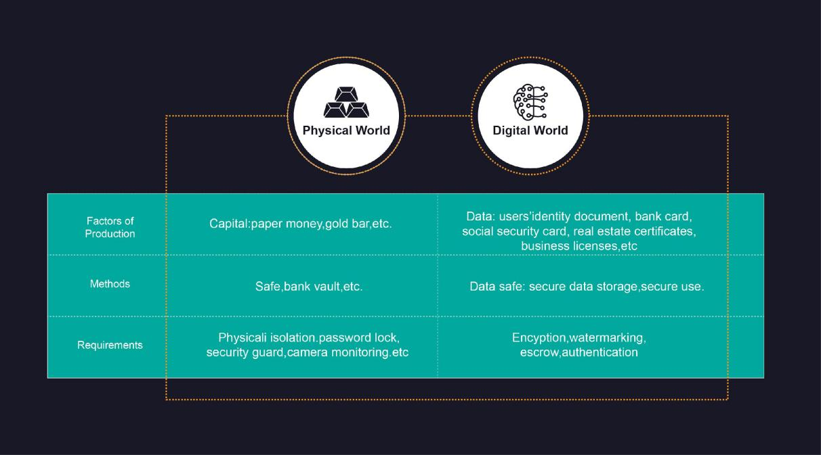

**Features**

**Multiple encryption techniques**

• The platform relies on multiple encryption techniques and domestic cryptographic algorithms recognized by the State Cryptography Administration for data protection.

• Coupled with a user password, on-chain data remains inaccessible without the user’s authorization.

**Key authentication and retrieve**

• Identify the one who stores and uses data through online authentication.

• Enable users to find their forgotten passwords through authentication.

**Escrow**

Make data traceable by storing operations such as uploading, querying, modifying, or using data on-chain.

**Tamper-proof watermarking**

Allow users to attach usage and validity watermarks to data in use so that the data can be used for proper purposes, preventing fraudulent use of the data.

**Blockchain network output**

Transmit data via the blockchain to partners to prevent the altering of said data during the transmission process.

#### Featured Applications:

**Finance**

Assist financial institutions with secure online storage and custody of client’s data assets used for loan applications or insurance purchases. These include identity documents, bank card photocopies, electronic invoices, electronic guarantees, insurance policies, and more.

**Cloud storage**

SP4C3 works with cloud storage service providers to provide secure data custody services, improve underlying data storage security, and protect customers’ data assets.

### A decentralized Financial Message Bus

At present, the challenges of large-scale service invocation under the multicenter distributed architecture primarily manifest in diverse ways. Internet business continues to boom, the number of distributed system services is increasing rapidly, the inter-system invocation relationship is diversified and complicated, and the service governance is more complex than ever before.

The number of services and DCNs keeps growing. The capacity of a single cluster and a single node is limited, so the expansion operation becomes more frequent, requiring high lossless requirements for the expansion business. The system has weak disaster capacity, complex switching, and high requirements for a non-destructive business of machine failure.

SP4C3-Bus support offers a diversified business call way, meet online, batch, big data processing scenarios, such as disaster of multicenter liveability and higher utilization rate of the machine, flexible, smooth upgrade and expansion methods, unlimited capacity, whole process service governance, and tools support, for the application, the bus itself and network fault isolation and automatic fast technological advantages, such as millisecond-level delay and 100-million-level message processing capacity, have helped financial companies meet challenges in an all-round way.

#### Industry-leading distributed architecture

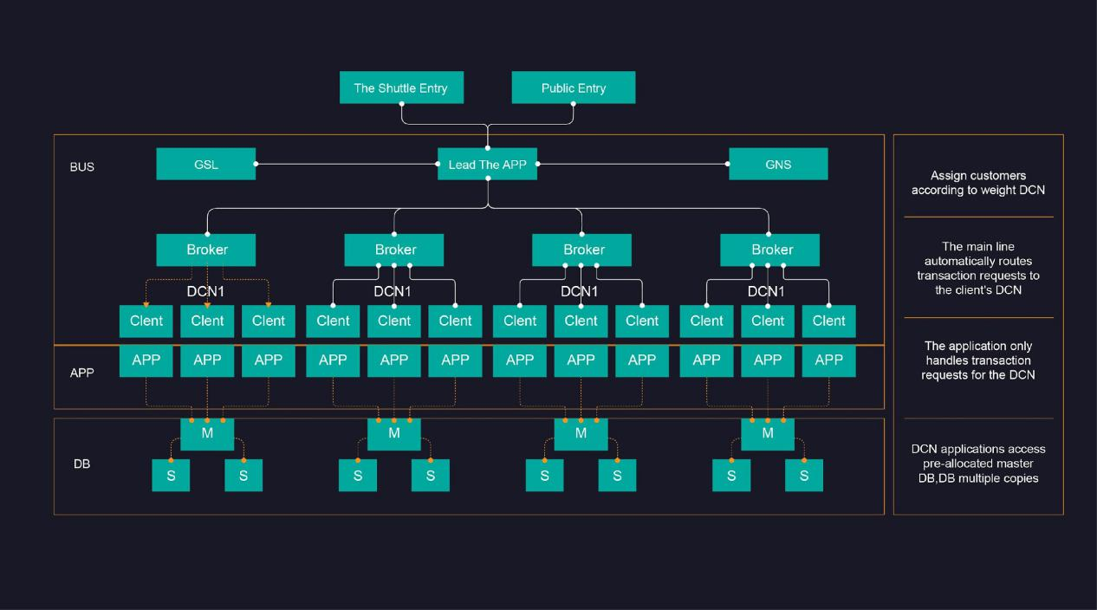

#### Bus architecture

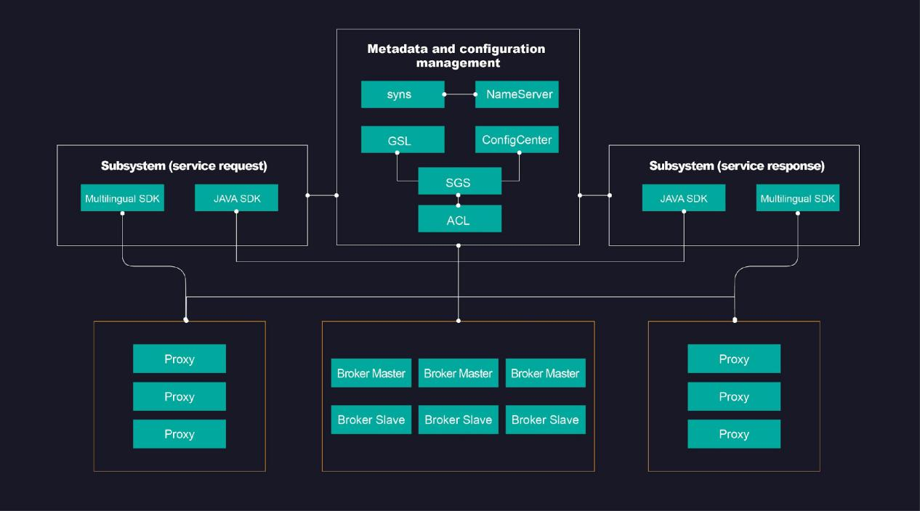

#### The major components：

**Broker**

Message storage capabilities are provided through lightweight Topic and Queue mechanisms. The broker periodically reports Topic information to a NameServer. The NameServer reported by the Broker instance in the cluster must be the same to avoid inconsistencies in routing information.

**NameServer**

Nameservers provide Topic discovery and routing. Each Nameserver receives Topic information reported by the broker and maintains Topic routing information for clients to query.

**SGS**

The service governance system is responsible for the overall service management, including service application, service deployment planning, service offline, and other service life cycle management. In this way, service and Topic correspond to each other one by one, and The corresponding service names topic names according to certain rules. SGS manages topic creation, update, and deletion after SGS creates Topics in the cluster of brokers corresponding to the deployment region of the service, the global service routing data updates for use by the GSL location service.

**GSL**

The global service location service provides service-level routing discovery. Services remain deployable in different regions (such as different data centers, logical partitions, etc.). When requesting a specific service, the service requester does not need to pay attention to the region requesting deployment. GSL can automatically locate the service according to the service discovery rules and return the service information to the client.

**Sync**

We deliver a unique, global nameserver data consistency service.

**Proxy**

The service proxy provides TCP/HTTP access while allowing access to clients in other languages such as C, Go, Python, etc., developed according to the protocol specification.

**ConfigCenter**

We are a configuration center that provides HTTP access, such as Namesrv addressing and other configurations.

**ACL**

Access control services, IP access control at the TOPIC level provide black and white list functionality.

#### Application scenarios

**Multicenter multi-active distributed service invocation**

Provide synchronous RR(Request-Reply), asynchronous unicast, multicast, broadcast, timing, and other ways of use.

**Distributed transaction**

Two-phase commit based on message implements distributed transactions.

**Distributed log storage**

Multi-replica consistent log storage based on TOPIC partitioning and RAFT.

**Connect the big data ecosystem**

Docking big data ecology, data synchronization of multiple data sources

### Distributed event-driven architecture

SP4C3-EventDriven is a distributed event-driven architecture, EDA, designed for preemptive, reliable, and in-time communications between complex and dynamic IT systems. It’s an open-source blockchain solution developed by SP4C3 for cross-institutional and cross-platform event notifications in loosely coupled systems that support the Collaborative Business models.

Aiming at higher efficiency of system communications, especially in multi-party cooperation, SP4C3-EventDriven connects different platforms such as applications, IOTs, cloud services, and private services by processing event notifications without altering the existing programming language and network interface protocols.

#### The Blockchain Solution

The blockchain-based EDA solution SP4C3-EventDriven allows publishers to send events on the blockchain with a reliable delivery mechanism and persistent storage, immutable from unauthorized changes, easier to trace and audit. Events are routed to subscribers with minimal coupling in terms of queues/topics and formats. SP4C3-EventDriven has high availability and is resilient to network outages and system failures, as events do not require acknowledgment and are inherently asynchronous. Additional publishers and subscribers can be added to the system without any changes to the existing infrastructure, which alleviates the risk of regression. SP4C3-EventDriven can detect patterns across multiple event sources over different time windows for continuous intelligence in terms of real-time analytics.

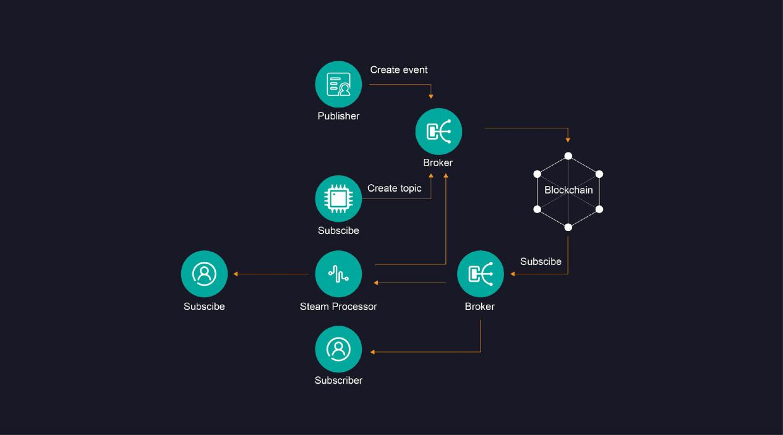

#### Stakeholders and Components

**Publisher**

EDA defines information flows between systems as event publications and subscriptions, where Publisher is the sender, and the subscriber is the receiver.

**Subscriber**

An enterprise or an individual can act as the Publisher or Subscriber in SP4C3-EventDriven. Generally in case of the Collaborative Business models stakeholder plays both these roles.

**Broker**

Broker is the middleware of communications between Publisher and Subscriber. Publisher broadcasts events to brokers with zero dependencies from the subscriber. Broker broadcasts events to different Subscribers for downstream processing.

**Stream Processor**

Stream Processor is the middleware to support complex event processing using customizable auto-filter, event analysis, and batch processing.

Understand the capabilities and value of the Stream Processor by comparing the following three combinations.

**Even-driven via a broker (handled separately)**

The broker handles one event at a time. The event is processed independently and can be directly sent to the event subscriber through the event agent, such as “submit an order information,” “issue a switch instruction,” etc.

**Even-driven by Stream Processor**

Multiple events (stream events) need to be analyzed. The network processes these events in batches (such as summation or counting) or via monitoring (such as raising an alert if the data exceeds a threshold.)These events are then channeled to the event stream calculator to generate complex events, then sent to the event subscriber through the event agent.

**The Broker and Stream Processor work together and complement each other to drive events**

In more complex business scenarios, some events require a combination of the two, such as a single credit card payment (processed separately) + a cumulative number of payments not exceeding the credit card payment limit (stream processing). The event flow calculator can act as a data source. The event flow sent through the broker can also be directed to the flow calculator, providing real-time and asynchronous composite event-driven computation in different customized combinations.

**Governance**

Governance is a set of components, or applications, with functions like event definition, SP4C3 vision, and access control. It’s a monitoring governance tool for Administrator to manage event topics and access control independently, separating administrative message stream from business events stream.

#### Feature Highlights

**Distributed**

A blockchain solution facilitates peer-to-peer cooperation, smart collaboration, and value sharing in the Collaborative Business model for higher efficiency in cross-institutional cooperation.

**Open Source**

The network remains open-sourced for greater transparency, co-innovation, greater security, extensive customization, and eliminating vendor lock-ins.

**Interoperability**

The broker supports multiple protocols, such as MQTT, STOMP, REST, and JSON RPC, to ensure interoperability.

**Customizable**

SP4C3-EventDriven is designed to separate control flow from data flow, event processing from flow processing and provides various modular SDKs for customizable development.

**Guaranteed Delivery**

Events will eventually reach subscriber once it is online.

**Loosely Coupled**

Broker decouples application logic with the underlying infrastructure, which allows you to link your application with SP4C3-EventDriven architecture seamlessly.

**Friendly Operation**

SP4C3-EventDriven provides a toolkit for on-chain governance.

**Scalability**

High scalability enabled by Smart Contract. Complicated events can be processed by Smart Contracts to make application services more scalable.

Privacy Protection

With event Governance and cryptographic measures, each stream of events will be created, stored, and processed with access control.

### Simplify IT management for distributed architecture

Applications today are growing into giant beasts while microservices are becoming a swarm. Regardless of your technology stack, the complexity of infrastructure in your organization will keep growing until it exhausts your employees. With SP4C3 Cube, you can now concentrate on doing your business rather than managing your infrastructure.

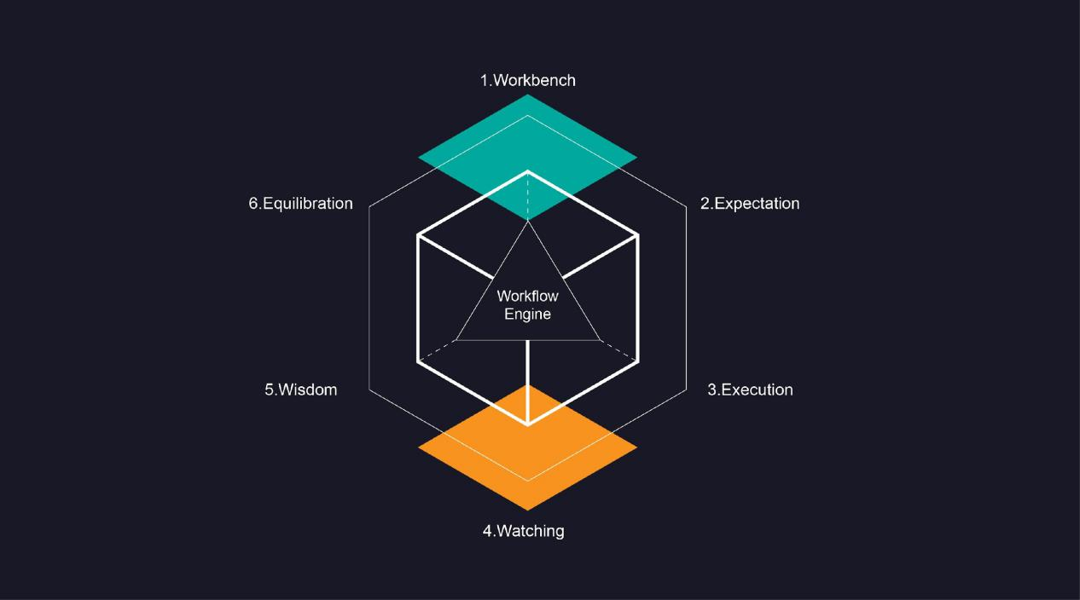

#### Design Concept

**Six-in-One Core**

1. Workbench

It is an ITSM-like workbench that can aggregate all manual tasks so that their contents, importance, and priorities are all clear at first glance.

2. Expectation

It is to plan, to design, to describe the expectations with models and specifications. By using standard and formal design language and graphic visualizations, we try to accurately and expectations on distributed architecture accurately and clearly.

3. Execution

It is to execute tasks in an automated and standardized way so that expectations become realities without introducing errors or deviations caused by people in this process.

4. Watching

It is to uncover differences between realities and expectations by defining all-around metrics that can reflect the varying runtime situation and then consistently collecting and keeping track of the information.

5. Wisdom

It is to add intelligence into SP4C3 Cube using data modeling and machine learning to develop policies to deal with errors and deviations, such as trouble shooting, cause analysis, and resource scaling.

6. Equilibration

It ensures that realities conform to design expectations by applying policies and making consistent adjustments so that running systems are stable in a dynamic way.

7.The core: Workflow Engine

It is to coordinate tasks and improve collaborations in those six aspects to reduce manual intervention and increase team efficiency.

**Plugin Extensions**

As a management framework for distributed IT systems, SP4C3 Cube keeps integrating with top-ranked open-source components employing plugins. It then forms a plugin marketplace, where users can choose the best plugin to use for their needs.

Resource Management Plugins for SP4C3 Cloud

The creation, modification, and destruction of various resources on the SP4C3 cloud are supported, for example, VPC, security group, virtual machine, NAT gateway, load balancer, MySQL, etc.

**Application Deployment Plugins**

The following operations are supported: file distribution, script execution, application deployment, the substitution of parameters, control of applications.

**Monitoring Plugins**

These plugins wrap in an unintrusive way to provide a user-friendly user interface and an easier configuration process. Implemented features include metric collection, alarm management, user view configuration, and threshold management.

### A one-stop, seamless experience, financial grade, and open source big data platform suite

The SP4C3 Date Sphere suite consists of 3 layers: the function layer, the middleware layer, and the basic layer.

The function layer provides rich tools to facilitate the data processing and analysis works, contains three-tiered toolkits for the platform, data, and application toolkit.

The middleware layer includes a computation middleware and a set of public enhancement services, enables easy connectivity between the function and basic layers and helpful management capabilities.

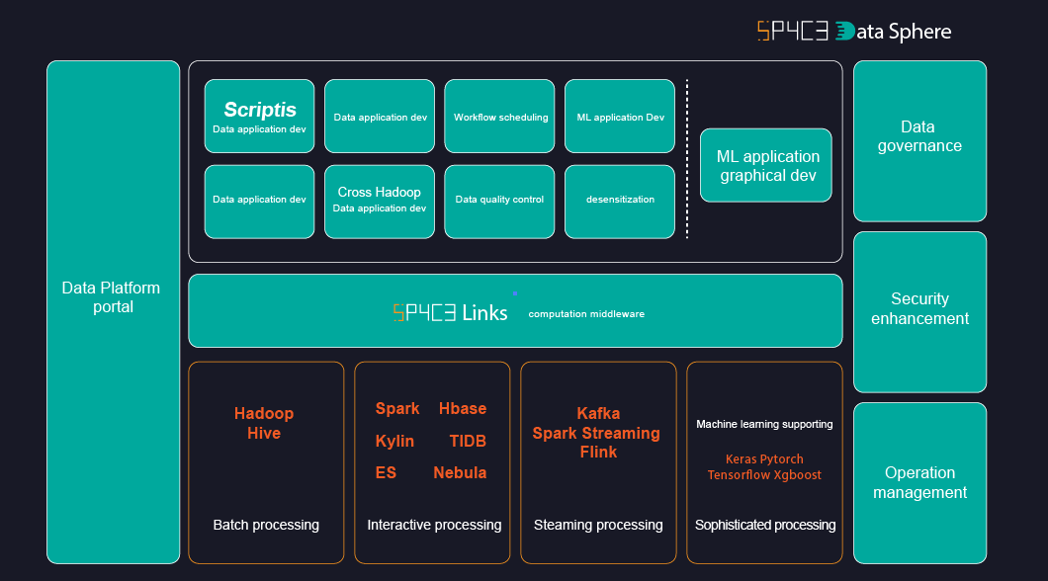

#### Functions and Tools

SP4C3 Date Sphere is a platform with financial grade computing, data storage, exchange, and machine learning capabilities developed based on various open-source components like Hadoop, Spark, HBase, KubeFlow, and FFDL. SP4C3 Technical Team made enormous enhancements and debugging efforts on top of the open-source components to tackle financial application issues related to security, performance, high availability, and traceability.

**Big Data Tools**

Platform Portal

Product map

Multi-tenancy management

Financial billing

Smart docking solution

Operational reporting

Cloud services

Middleware SP4C3 Links

Financial grade multi-tenancy

Resource planning

Access control

Application & storage layers connector

Platform Portal

Cluster management

Configuration management

Change management

Service request automation

One-click installation and upgrade

Graphical operations

Monitoring and diagnosis

Self-healing

**Data Tools**

Data Map

Manages data resources of the entire bank, including modules like metadata management, data permission, data lineage, data quality, data model, and others.

Data Masking

Supports data masking and desensitization for high-security level data to prevent users from accessing original data.

Data Quality

Standardized processes to define and test the quality of data sets and report issues in time.

Data Transmission

The Cross Hadoop clusters data sync tool supports data transmission tasks regarding dispatching, status, statistics, monitoring, etc.

**Application Tools**

SP4C3 Scripts

Web-based integrated development environment supports docking multiple computing storage engines, multiple programming languages, and data visualization.

Scheduling System

Provides a graphical interface for workflow definition and executing schedules and supports dependency display, status view, historical statistics, monitoring configuration, etc.

Data Presentation BI

Provides a drag-and-drop graphical interface and supports simple script compiling. All graph reports can be auto-sent recurring and periodically.

Machine Learning Support

The machine learning system adopts various model training methodologies, integrates self-developed machine learning algorithms and open-source frameworks, and supports high-performance clusters for multi-tenancy management.

#### Feature Highlights

**Your one-stop for a seamless, financial grade, open-source experience.**

One-Stop-Shop

SP4C3 offers rich, functional tools featuring three-tiered toolkits (platform, data, and application) and advanced machine learning capabilities.

Seamless Experience

SP4C3’s visual drag-and-drop experience, unified UI, and context sharing between different functional modules for the overall data application workflow development makes interfacing with the software easy.

Financial Grade

Cross cluster high availability, complete data governance solution, and enhanced security in all layers full-filling the financial level business continuity and regulatory requirements.

Open Source

Contribute SP4C3’s big data platform success back to the community through the SP4C3 Date Sphere suite. Keep community version in sync with SP4C3 production ENV version to ensure completeness and quality.

#### Computation Middleware -SP4C3 Links

To solve the docking and re-usage issues of tools and application of the back-end’s front-end and computing storage engines.

|  |  |
| --- | --- |
| Support Application Layer | Unified interface  High concurrency, distributed systems, resource management, and user access control |
| Connect Computing Storage Layer | Fast and easy access  Multi write, multi-read, hybrid computing, retry, playback, and other functions are available at any time |
| Open Upper and Lower System | No application silo  Data kinship, code generality, user resources are collaborative |

By connecting with SP4C3 Links front-end system, you can quickly obtain the financial grade multi-tenancy, resource management and control, authority isolation and other capabilities, the unified variable, function and resource file management across poly-frontend system capabilities, and the advanced computing strategy, high concurrency, high performance, and high availability big data working / request life cycle management capabilities.

The microservice architecture supports plugin docking of various big data computing storage engines in the back-end, enabling the user’s data development/display tool system to be upgraded to meet the dynamic needs of the given situation.

#### Analytics Tool -SP4C3 Scriptis

Powerful enterprise-grade features like multi-language, multi-engine, multi-tenancy, resource management and control, intelligent diagnosis, and more.

Data Application Development

• Script language: SQL/Python/R/Scala/Shell and others

• Computing engine: Spark/Hive/Hbase/JDBC/Python/Shell and others

• Syntax: auto-complete, highlight, error correction

More Systematic

• Library management: table data exploration, quick query, and table management

• Data exchange: fast import and export of different file formats

• Function management: customized UDF / Python / Scala UDF

• Context: system variables and custom variables

Secure and Reliable

• Resource management: system- and user-level resource isolation

• Application management: system- and user-level application isolation for multi-tenancy

• Task management: full life cycle control in a real-time, historical task tracking

• Console: one-stop configuration of engine parameters and resource files

More intelligent

• Intelligent optimization: intelligent engine selection, intelligent retry

• Intelligent evolution: scripts and parameters optimization

• Intelligent diagnosis: data skew diagnosis, job health diagnosis

• Intelligent error code: user-friendly error codes along with corresponding solutions

## SP4C3 Distributed Storage Service, DSS

SP4C3 Distributed Storage Service (DSS) provides you with dedicated storage pools which are physically isolated from other pools to ensure high security. DSS delivers reliable, durable, low-latency, and stable storage resources with data redundancy and cache acceleration technologies. By flexibly interconnecting with various compute services, such as Dedicated Computing Cluster (DCC), Elastic Cloud Server (ECS), and Bare Metal Server (BMS), DSS is suitable for different scenarios. These suitable scenarios include high-performance computing (HPC), online analytical processing (OLAP), mixed loads, and more.

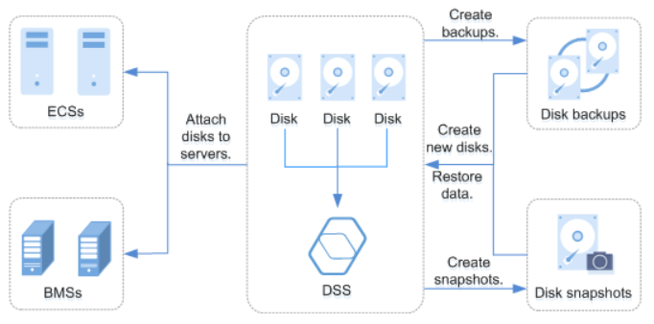

### Function Characteristics

* Rich specifications
  + High I/O: Suitable for scenarios that require high performance, high read/write speed, and real-time data storage.
  + Ultra-high I/O: Excellent for read/write-intensive scenarios requiring extremely high reading and reading/write speed and low latency.
* Elastic scalability
  + On-demand capacity improves resource utilization.
  + Linear performance increase can be achieved with capacity expansion.
* Security and reliability
  + Distributed storage with three data replicas ensures 99.9999999% durability.
  + System disks and data disks support data encryption with zero application awareness.
* Backup and restoration
  + It is possible to create backups for a DSS disk, restoring the disk data, maximizing data security and correctness, and ensuring service security.

Users can use application programming interfaces (APIs) to perform operations on DSS resources, such as creating, querying, deleting, and updating DSS resources.

|  |  |
| --- | --- |
| **API** | **Description** |
| Obtaining Details of a DSS Storage Pool | Obtain the details of a specified DSS storage pool, including the pool name, ID, capacity, type, and creation time. |
| Obtaining Details of DSS Storage Pools | Obtain the DSS storage pools requested by the tenant, including the pool names, IDs, capacities, types, and creation time. Filter query and pagination query are supported. |

SP4C3 Distributed storage service

## 

## AI Cloud Computing

AI computing chip and hardware support will use the intelligent server supported by AI intelligent chip, greatly reducing the difficulty and cost of distributed storage-related AI application development. This process supports the continuous iteration of the algorithm, greatly improving the analysis and invocation of distributed storage data and the efficiency of data interaction.

**AI Ecosystem： Build strong AI capabilities to power highly scalable financial and non-financial applications.**

### Financial application support:

**Alternative Data Analytics**

Transform massive alternative data (satellite imagery, IoT data, social media data, etc.) into actionable insight

**Pioneering Investment Research**

Monitor and forecast economic system in a real-time, independent, efficient fashion to deliver investment signals such as ESG index

**Leading Interactive Finance**

Visualize unstructured alternative data and identify financial risks by leveraging knowledge graph

#### Application type:

KYC for Account Opening

OCR / face / live body / voiceprint / ASR /

speaker / conversational system / dactylology

Customer Service System

ASR / conversational system

Quality Inspection System

Conversational learning / image / OCR

### Non-financial application support:

It has a self-training function based on the AI computing power center and corresponding algorithm institute and combining with the AI model. The analysis ability will be continuously improved, serving the urban, comprehensive management and meeting different industries’ AI computing power needs.

**Integrated service algorithm：**

Including face algorithm, vehicle algorithm, structured algorithm, behavior analysis, combined with satellite remote sensing images and corresponding real-time data (including weather, ocean, seismic detection, etc.) constitute algorithm resource pool.

The algorithm of different ecological partners is continuously introduced to carry out scheduling and operation according to demand.

**End-to-end cloud collaboration**

Through the distributed system, SP4C3 uniformly schedules the AI computing power according to the needs. The regional end is responsible for the light processing, and the AI cloud is responsible for the in-depth analysis, which greatly improves the efficiency.

**Improve the efficiency of urban management**

The intelligent identification system is mainly provided for the video resources connected to the AI computing pool by the requirements of users and public-safety standards to help reduce the government expenditure in this area and improve the efficiency of urban public safety management

**AI Supercomputing Cloud (Supercomputing Center system)**

Through computing power dispatching management platform, forming the AI superpower, breaking the traditional supercenter monopoly on AI workforce, under the condition of meeting the terms of the international counter-terrorism KYC, any organization can be called SP4C3 workforce to form an AI into a superpower, and cooperate with the corresponding algorithm to complete research projects (including the meteorological, oceanographic, large research and development of science and technology category). This process greatly reduces the use of supercomputing cost and entry conditions.

#### Application type:

Intrusion detection, intelligent security system

Disaster emergency command and rescue（ Broadcast Emergency Response）

Intelligent management of the prison

Intelligent city police dispatch

Special traffic vehicle monitoring

Intelligent Personnel Identification and Search (Child Alert、AMBER Alert)

Intelligent access control, video, temperature and humidity monitoring (fire control, dangerous goods control)

## Main application

### Main application scenarios in the early stage of SP4C3:

#### Application of SP4C3:

1. DeFi Open Financial System: Supports distributed storage requirements for cross-chain atomic exchange and cross-chain atomic mapping

Provides support for resolving data interactions.

1. Bank payment system: Cross-chain interaction with the Ripple community to provide more efficient and secure data storage and data invocation for the bank payment system it serves.

Learning from Ripple’s Interledger Protocol, and based on the Ethereum network, SP4C3 greatly improves the efficiency of transmission and data invocation for the protocol users in the data storage of electronic receipts, third party data invocation, submission, and execution of the protocol, by using intelligent server of the AI chip, which also improves the security and secrecy of the data. SP4C3 will support the development, application, and implementation of Interledger Protocol through secure and efficient distributed storage, including the management and recording of commercial society, banking institutions, and government, and the establishment of unchangeable notary business.

1. Cross-chain Bridge of transaction ecosystem: it serves Binance Bridge technology to provide high-security data storage and invocation services. It later extends to serve other transaction systems to ensure the security and efficiency of data storage.

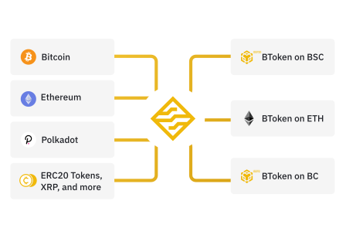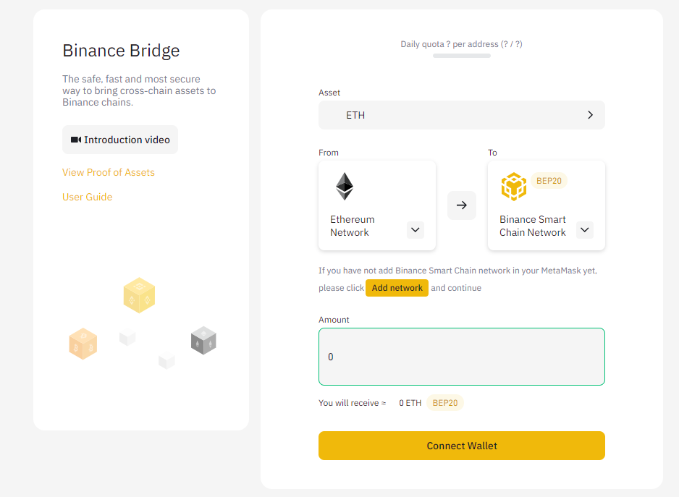

●Ring signature - The digital signature system based on distributed storage ensures the secret and security of electronic signatures in the digital financial system.

Ring signature is a type of digital signature that remains performable by any member of a set of users that each has keys. Therefore, a message signed with a ring signature becomes endorsed by someone in a particular set of people. One of the security properties of a ring signature is that it should be computationally infeasible to determine which of the set’s members’ keys was used to produce the signature. Ring signatures are similar to group signatures but differ in two key ways: first, there is no way to revoke the anonymity of an individual signature, and second, any set of users can be used as a signing set without additional setup.

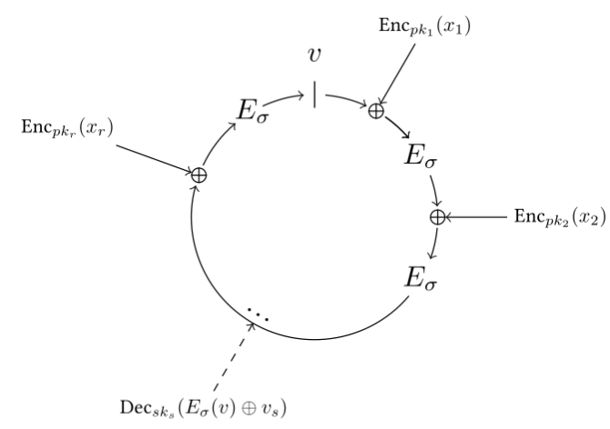

For instance, a ring signature could be used to provide an anonymous signature from “a high-ranking White House official” without revealing which official signed the message. Ring signatures are right for this application because the anonymity of a ring signature cannot be revoked, and the group for a ring signature can be improvised.

Another application, also described in the original paper, is for deniable signatures. Here the sender and the recipient of a message from a group for the ring signature, then the signature is valid to the recipient. Still, anyone else will be unsure whether the recipient or the sender was the actual signer. Thus, such a signature is convincing but cannot be transferred beyond its intended recipient.

There were various works, introducing new features and based on different assumptions:

Threshold ring signatures

Unlike the standard “t-out-of-n” threshold signature, where t of n users should collaborate to decrypt a message, this variant of a ring signature requires t users to cooperate in the signing protocol. Namely, t parties (i1, i2, ..., it) can compute a (t, n)-ring signature, σ, on a message, m, on input (m, Si1, Si2, ..., Sit, P1, ..., Pn).

Linkable ring signatures

The property of likability allows one to determine whether any two signatures have been produced by the same member (under the same private key). The identity of the signer is nevertheless preserved. One of the possible applications can be an offline e-cash system.

Traceable ring signature

In addition to the previous scheme, the signer’s public key is revealed (if they issue more than one signature under the same private key). An e-voting system can be implemented using this protocol.

#### Unique Value Proposition:

● Verifiable storage - Sp4ac3 verifies if the user’s data is stored with encrypted authentication without relying on the cloud storage provider or other intermediates.

● Open Participation - Any party with the required hardware system and access to the Internet can participate in the Sp4ac3 system.

●Storage distribution can be locally optimized - Driven by open participation, market power in the Sp4ac3 economy can deliver information and data more efficiently than a centralized storage platform, and the network will have faster response times.

Sp4c3 stored data in a distributed nodes network efficiently and economically will increase the versatility of the network. For example, users have easy access to the data or information they want to acquire from nearby nodes of the Sp4c3 network.

●Flexible Storage Options - As an open platform, Sp4c3 will support many additional tools and ancillary services and payments through different blockchains(Bitcoin, Ethereum, Ripple)

● The network is built by the community - SP4C3 allows Ethereum network participants to become stakeholders in the network's success, and the network will grow stronger as a result. SP4C3 participants will benefit by working together to improve the Ethereum network.

● Cross-chain support - Sp4c3 will be based on cross-chain agreements with more partners, using blockchain bridges and on-demand expansions

●Support for non-financial applications - through the AI computing space, access the video and supervisory resources connected to the AI computing, according to different types of applications combined with different algorithms, provide intelligent monitoring and identification, and through the system warning, to solve different types of needs.

### Service Objects of SP4C3:

Virtual (digital) banks and digital funds: Virtual (digital) banks and digital fund institutions: Secured and distributed data storage will be convenient for digital banks and fund institutions to store, access, transfer, review, and audit.

Digital trading platform: SP4C3’s powerful Data processing capability can support high concurrency and precise digital asset transaction interaction of different degrees. Its distributed Data storage is more conducive to asset security.

Digital Wallet Agency: SP4C3, secure, transparent, and traceable, enables digital wallet organizations to form an integrated platform, including relevant Data storage and invocation, to help store and transfer digital assets in the ecosystem.

Data Manager: Use SP4C3 to store archival Data for Data deduplication, cluster persistence, and high performance.

Service Provider: Offers large amounts of data to users, and storage on SP4C3 can help you cut bandwidth costs thanks to secure peer-to-peer content delivery.

Researcher: Processing or distributing large Data sets, using SP4C3 to store this data can help improve performance and unlock decentralized archives.

Government agencies: Through the use of SP4C3 distributed storage and AI cloud computing system, combined with different algorithms to help improve the efficiency of urban, comprehensive management, and help disaster emergency prediction, management, control, and processing capabilities.

For example:

City security and airport management and control, through structured video processing and cloud data information, the personnel information of terrorists or specific objects can be automatically detected, identified, and analyzed. The analysis results that are easy for automatic judgment or manual judgment can be formed. At the same time, it can conduct intelligent analysis of human actions and objects, provide early warning information and automatically transmit information with relevant police for the alarm to realize high-speed automatic processing of video image information, which is an important support for comprehensive application of video image information.

Emergency management and control, such as epidemic control, can support the automatic access to personnel information where the epidemic occurs (large public places) and intelligent analysis of information of high-risk groups present at the same time according to relevant local laws and regulations and privacy provisions. And the corresponding data will be transmitted to relevant medical institutions and epidemic prevention organizations for early warning.

Various enterprises and organizations: According to different needs, SP4C3 provides corresponding AI algorithms and data storage services by combining the Internet of Things and AI devices through image acquisition.

For example:

It provides energy consumption information management and dangerous goods numerical real-time monitoring and analysis for energy enterprises to achieve dangerous goods warning and monitoring.

The Cloud AI analysis of location data for transportation enterprises can intelligently identify vehicles that deviate from the normal route or exceed the normal speed and automatically issue an alarm.

Blockchain Developers: SP4C3 can store large files off the chain and place immutable, permanent Links -- timestamps and protected content -- in transactions without having to put the data itself on the chain.

Content creators: Enables creators to build and share on decentralized networks -- whether providing content that is not subject to intermediate control or forging NFT that will stand the test of time.

Offline users: High-latency networks pose a major barrier for those with poor Internet infrastructure. Point-to-point SP4C3 provides flexible access to data without delays or main network connections.

## 

## Participants in the SP4C3 economy

Based on the supply and demand trend in the market, the difference between distributed storage networks and cloud storage modes will promote significant improvement and growth of efficiency.

### Participants in the SP4C3 economy:

In an SP4C3 economy, there are three different markets where participants in the network exchange different goods or services.

Storage market

First, the storage market, where the storage Hardware Providers rent out available digital storage, which the SP4C3 network will verify, and users will pay SP4 for the storage. Storage pricing is based on available storage capacity and the term of the storage contract.

Second, the Search Engine Market, where Customers pay SP4 for Hardware Providers’ data.

The third market, the secondary market (The exchange market), is where participants exchange tokens for transferring SP4 to improve the circulation of SP4. In the retrieval.

The diagram below illustrates the common interaction among five main stakeholders:

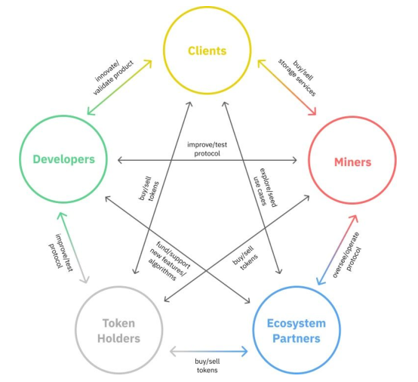

The SP4C3 economic model is based on data storage, with storage Hardware Providers playing a central role in ensuring on-chain consensus and providing storage services. SP4C3 uses its block awards to subsidize consensual participation and availability of storage services on the Ethereum chain. This section describes how to provide storage services on an SP4C3 network and explains the concepts and frameworks for taking storage on different machines and devices and turning it into tradable goods in a distributed storage network.

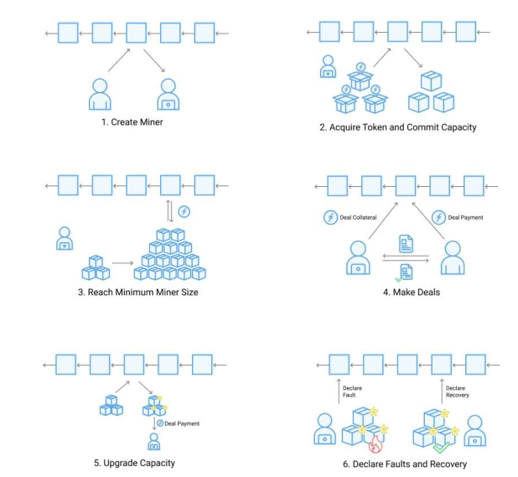

### 

### 

## Economic Model:

SP4 distribution rules are as follows: The minting limit is 100 million SP4, called SP4C3 BASE.

In SP4C3’s creation block distribution, 10% of SP4C3 BASE is allocated to financial institutions, and 15% of SP4C3 BASE is allocated to the protocol laboratory (including 4.5% to the laboratory team and contributors),

5% is allocated to the SP4C3 Foundation.

The remaining 70% is allocated to SP4C3 Hardware Providers as rewards, used to provide data storage services, maintain the blockchain, distribute data, run contracts, etc.

|  |  |
| --- | --- |
| SP4 Allocation | |
| SP4C3 Foundation | 5% |
| PL Team&Contributions | 4.5% |
| Joint project Labs | 10.5% |
| **Financial institutions and banks hold** | **10%** |
| Reserve | 15% |
| Storage allocation | 55% |

**Declaration: Any personal investment will not be accepted, and any unauthorized transfer will be ignored. Thank you for your support.**

### Deflation Model：

### After the main network launches, the output will fall by 5% per year, keeping SP4C3’s economic ecology deflationary.

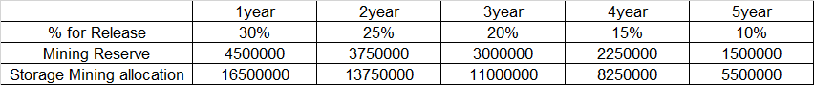

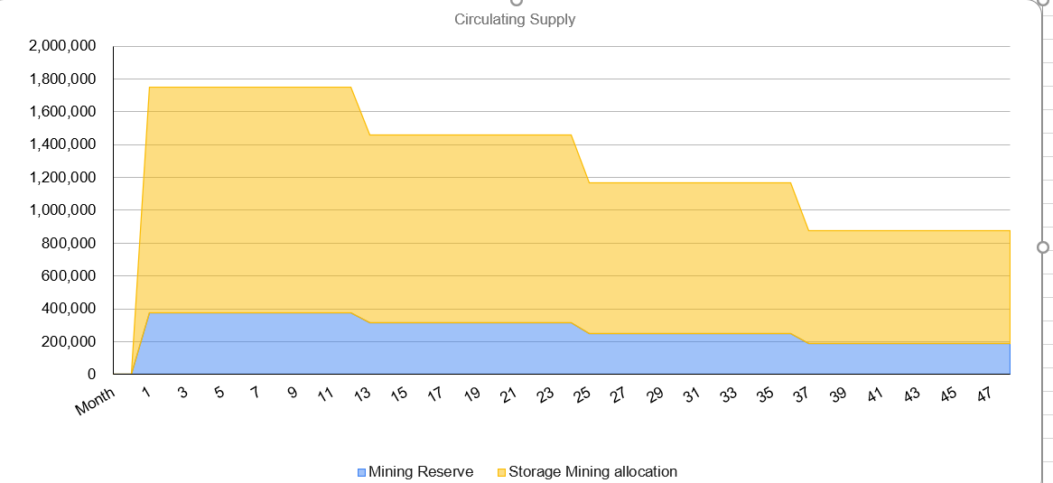

### 

### The Collateral Mode:

SP4C3 must obtain network security by contributing storage resources. However, it should be noted that SP4C3 is designed to use lower-cost commercial hardware equipment, which means that the attacker’s hardware costs are also reduced. To prevent this risk, SP4C3 also uses the Token Collateral Method proportional to the promised storage hardware equipment to increase the cost of the attack.

This process has its advantages: attacking a network requires acquiring and running hardware and acquiring many tokens.

To minimize the burden on Hardware Providers, the amount of collateral token is set to be the minimum requirement.

SP4C3 has three different collateral mechanisms:

#### Initial Collateral Mechanism awards Hardware Providers with the initial collateral token, used as future collateral.

The institutions will deposit the initial collateral. The Hardware Providers in the early stage will be able to apply for participation through the test network and determine the initial collateral quota. In the later stage, Hardware Providers can purchase SP4 from the market to participate in collateral.

#### The second mechanism is to reduce the initial token collateral requirement through block reward lockup. Rewards are issued: 21.5% will be released immediately, and 78.5% will be released linearly in 180 days.

#### The third is to establish incentives between Hardware Providers and users. The agreement requires minimum collateral to provide minimum storage. If the transaction order is terminated prematurely, this collateral will be confiscated. However, Hardware Providers can offer higher transaction collateral, which means a higher reliable service to potential users.

### Stores Rewards

Hardware Providers are the only group who are allocated incentives when the network goes online. It is also the earliest group of Hardware Providers.

They are also responsible for maintaining the core functions of the protocol. So the largest share of the rewards goes to this group, 55%.

SP4C3 BASE (78.6% of awards). Rewards primarily distribute this portion of the reward to maintain the blockchain, run contracts, and subsidize reliable and useful storage. This section will also cover early Hardware Providers rewards.

### Bonus Reserve

### 

The SP4C3 ecosystem needs to ensure that all Hardware Providers have incentives (such as Search Engine Hardware Providers, maintenance Hardware Providers, and future Hardware Providers whose type is currently unknown) to build a robust economy. To ensure that the network provides incentives to other types of Hardware Providers, 15% of SP4C3 BASE (21.4% of rewards) is set aside. The community could decide how to distribute these tokens in the future through SP4 Improvement Proposals or similar decentralized decisions. For example, the community could decide to create incentives for search engines and other activities. Like other blockchain networks and open-source projects, the SP4C3 network will continue to evolve, adapt and overcome challenges for many years to come. Setting aside these token reserves provides more flexibility for future Hardware Providers and ecological communities. Other unsubsidized activities, such as search engines, are also important to SP4’s economy, and these activities arguably require a higher percentage of rewards. Over many years as the network evolves, the community can decide whether the reserve is sufficient and whether it needs to adjust the remaining tokens.

### GAS consumption:

**SP4C3 belongs to the blockchain economy, where participants can conduct transactions over a decentralized network and then update the state of the network by writing and processing messages in their blocks. This process includes data and messages.**

**Running transfer data and messages consumes computing and storage resources on the network. Here, “GAS” is used to measure the resources consumed. The data consumed directly affects the cost to the sender of submitting the message to the blockchain. In addition, the total amount of “Gas” for all messages in the block is limited so that gas can be considered fuel for the SP4C3 blockchain, just like fuel for a car. Before taking a road trip, drivers need to determine the mileage and pay for their gas to power their engines on hillsides and downhills.**

**GAS consumption is divided into two main parts: GAS consumption to increase computing power and GAS consumption to maintain computing power.**

## Road Map:

**Project Timeline and Key Points:**

### Q3 2020:

**1. Launching the official website and starting the construction of distributed ecosystem technology architecture based on Ethereum & Ripple;**

**2. Establishing the first five distributed storage SP4C3 nodes, including North America (Canada, the United States), South America (Ecuador, Savaldo), Eurasia (Russia, Switzerland, the Netherlands, Lithuania), and Oceania (New Zealand), and build project communities;**

**3. At the same time, starting global business cooperation based on distributed storage to build cross-chain laboratory;**

**4. The project committee will be established, and the legal compliance procedures will be completed.**

**5. Starting the construction plan of the underlying transport protocol and constructing the distributed storage & AI cloud computing power management system.**

**6. Distributing for the first time to participate in the publication of storage & AI Cloud computing hardware related test parameters;**

**7. Release the first test plan (for the computing power management platform).**

### Q4 2021:

**1. Improve and update the project committee and start constructing financial system distributed storage technology architecture.**

**2. Distributing storage & AI cloud computing power-related test parameters will be announced.**

**3. Releasing the second test plan (For the application layer）**

### Q1 2022:

**1. Version1 of the storage and computer testing network is online**

**2. Released version 1.0 of A financial-grade secure data storage, Decentralized Financial Message Bus, Distributed event-driven architecture, Simplify IT management for distributed architecture, and A one-stop, seamless experience, financial grade, and open source big data platform suite, and completed open source.**

**3, Ethereum & Ripple and other multi-chain cross-chain protocols to test network interaction.**

**4. Started the process of launching Coinbase, submitted the application and relevant materials.**

### Q2 2022:

**1. SP4C3 global hardware SP4C3 node construction and test network to assist the operation**

**2. DAO members confirming and carrying out the first community autonomy vote**

**3. Starting the docking of data storage and computing technology support between banks and financial institutions**

**4. Initiating the plan of establishing a laboratory jointly with the hardware support organization to ensure the iterative coupling degree between hardware and software**

**Q2 2022：**

### 

### Q3 2022:

**1. SP4C3 main network launching;**

**2, Ethereum & Ripple and other multi-chain cross-chain protocol Bridge building**

**3. The data storage and computing service system of banks and financial institutions go online**

**4. SP4C3 providing relevant Data to hardware partners, conducting technology docking, taking distributed storage and AI cloud computing as the core direction of research and development, and obtains hardware iteration support.**

**5. Starting capital operation and announce IPO plan. (The plan will also be considered in the form of SPAC）**

### Q4 2022:

**1. Release the iteration plan for launching SP4C3 main network (including software system upgrade, hardware support iteration test Data, etc.)**

**2. Officially launched Coinbase and started secondary market trading on other mainstream trading platforms**

**3. Start the asset securitization business in the project capital market**

**4. Update the project progress report quarterly, and release the project planning and core objectives for the next year**